Deliverables for Milestone 1

Use Cases Description 1

Use Case Diagram 2

User Stories 2

List of Functional and Non-Functional Requirements 3

CRC Cards for User Stories 3

UI Mockups 4

# Use Cases Description

**A user browses the catalogue (whether logged in or not)**

The user visits the web platform.

The system shows products.

The user can view detailed product information.

**An unregistered user register on the web platform**

The user clicks the registration button.

The system requires the input of username/email and password.

The user enters username/email and password.

The system checks the entries.

The system requires the input of additional information.

The user enters additional information.

The system saves the user input and creates a new user.

The system shows the login window.

-> if username/mail is already existing, show a warning and go back

-> if information is missing, show a warning and go back

**A registered user login to the web platform**

The user clicks the login button.

The system requires the input of username/email and password.

The user enters his login credentials.

The system checks the entries.

The system changes the status of the user to logged in.

-> if username or password is invalid, show warning and go back

-> the user can click the forgot password button

# Use Case Diagram

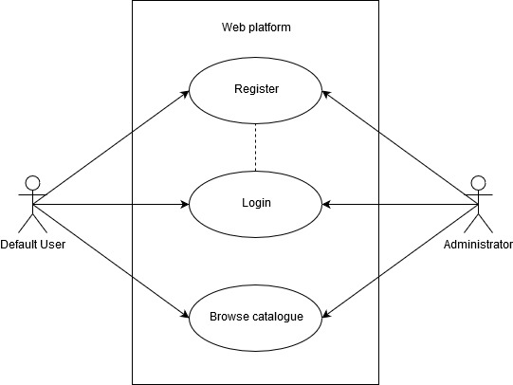

https://www.diagrammeditor.de

# User Stories

As an unregistered user, I want to register, so I can login to the web platform.

As a registered user, I want to log in, so I can make full use of the web platform.

As an unregistered user, I want to browse the catalogue, so that I can see the products before I must register.

As a registered user, I want to buy and sell products.

As an administrator, I want to approve/disappear products by users, so I can check before they get posted.

# List of Functional and Non-Functional Requirements

**Functional:**

Register a new user

Login a registered user

Browse the catalogue

Sell and buy products

**Non-Functional:** (see [example](https://web.cse.ohio-state.edu/~bair.41/616/Project/Example_Document/Req_Doc_Example.html#Nonfunc))

Security: User data must remain confidential

Supportability: The web platform should run on all standard browsers

Performance: for example max. 5 seconds for login

Usability: The system should be easy to use

# CRC Cards for User Stories

**User**

ID, name, private Information,

*approve & disappear or buy & sell products (collaboration with product)*

**Product**

ID, name, price, category

*user information of the seller (collaboration with user)*

(Category, Wallet, Order)

# UI Mockups

